**Fooling AI image classifiers**

**OUTMANI Ossama**

**ossama.outmani@etu.uae.ac.ma**

**Supervised by P.KHAMJANE Aziz**

**akhamjane@uae.ac.ma**

**Department of Mathematics & Computer Science, Abdelmalek Essaadi Univ.**

**ENSAH College, Alhoceima, Morocco.**

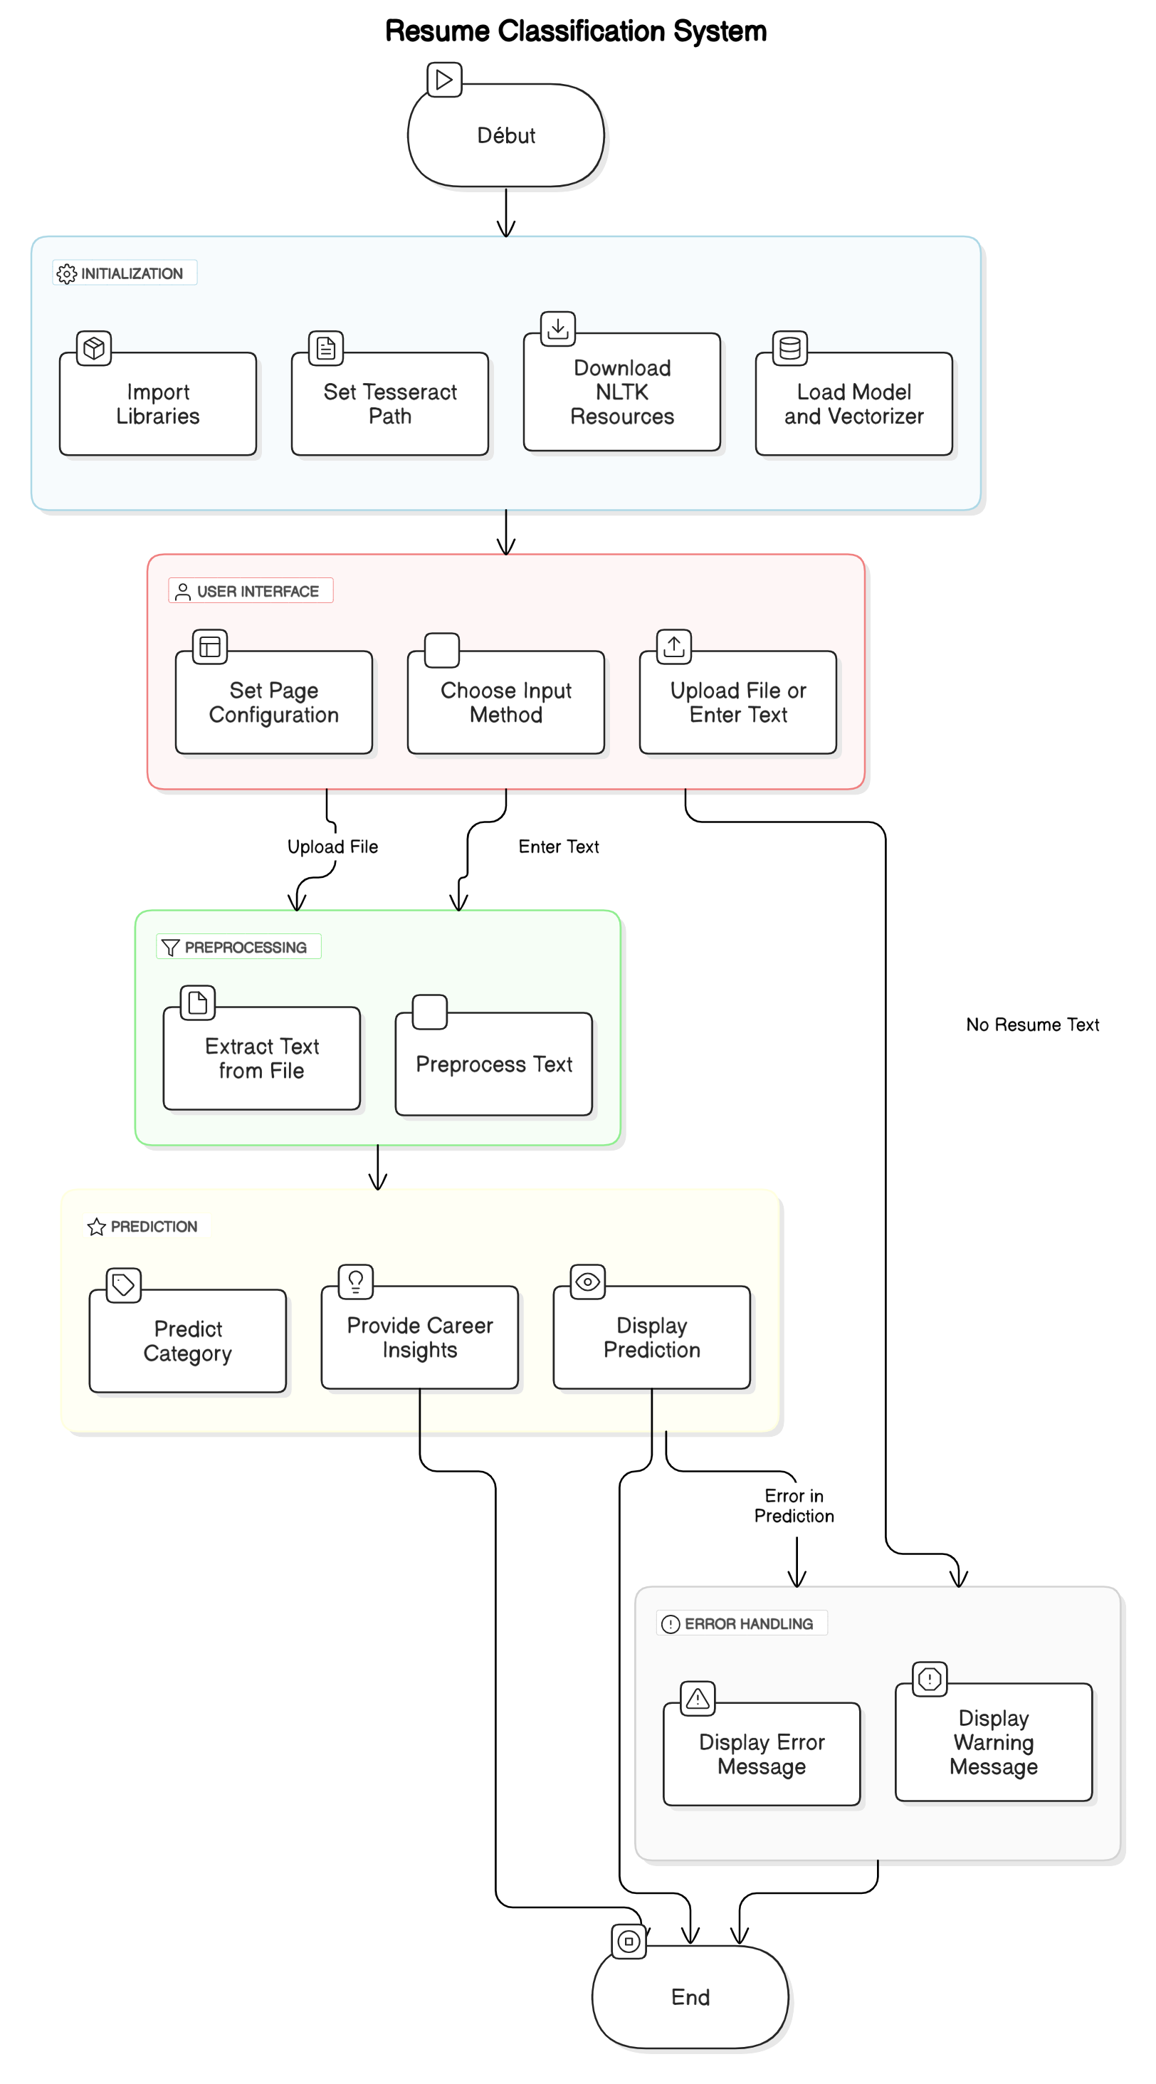**figure 1:** Architecture Globale du Système